**Project : E-commerce App**

**Rollno :**

Rukhsar_Nisar-20W137

Tanzeela_Rind-20SW121

**Assigned By : Ms Mariam Memon**

**Report Contains :**

-Problem Identification

-Proposed Solution

-ScreenShots

-Data Storage

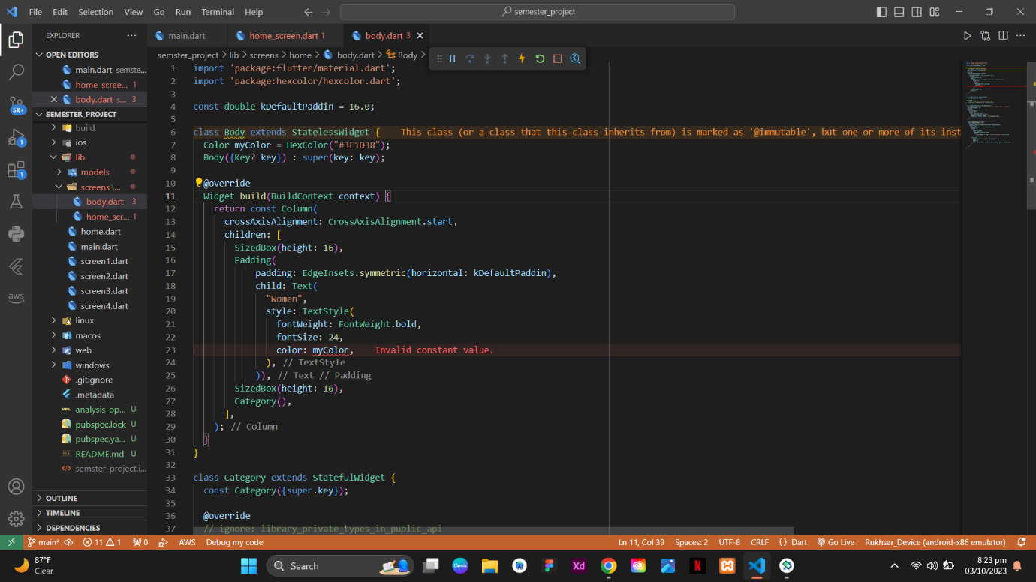

**Problem:**

I have set const Column that’s why constant value shows error.

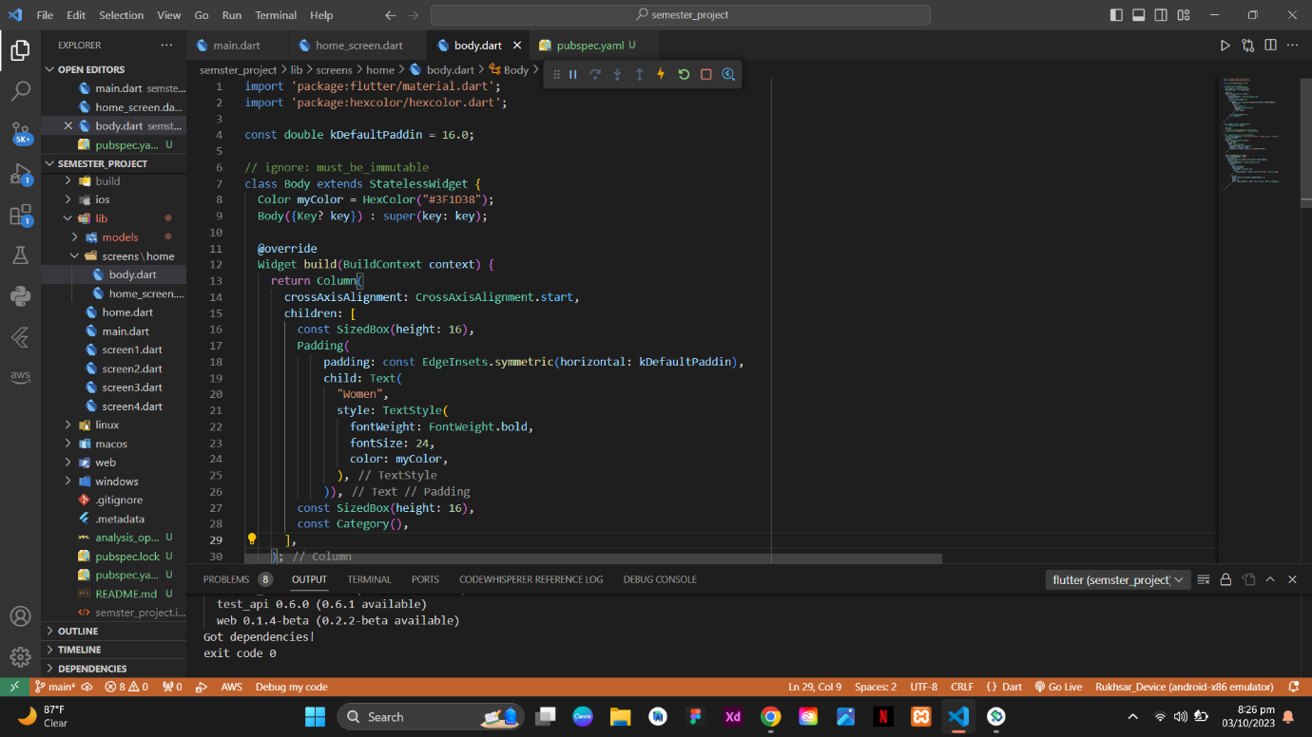

**Solution:**

Import ‘package:hexcolor/hexcolor.dart’;

Initialized it first as:  
Color myColor = HexColor(“#3F1D38”);

Remove const keyword before Column, Now you are able to use constant value(myColor) whereever you want.

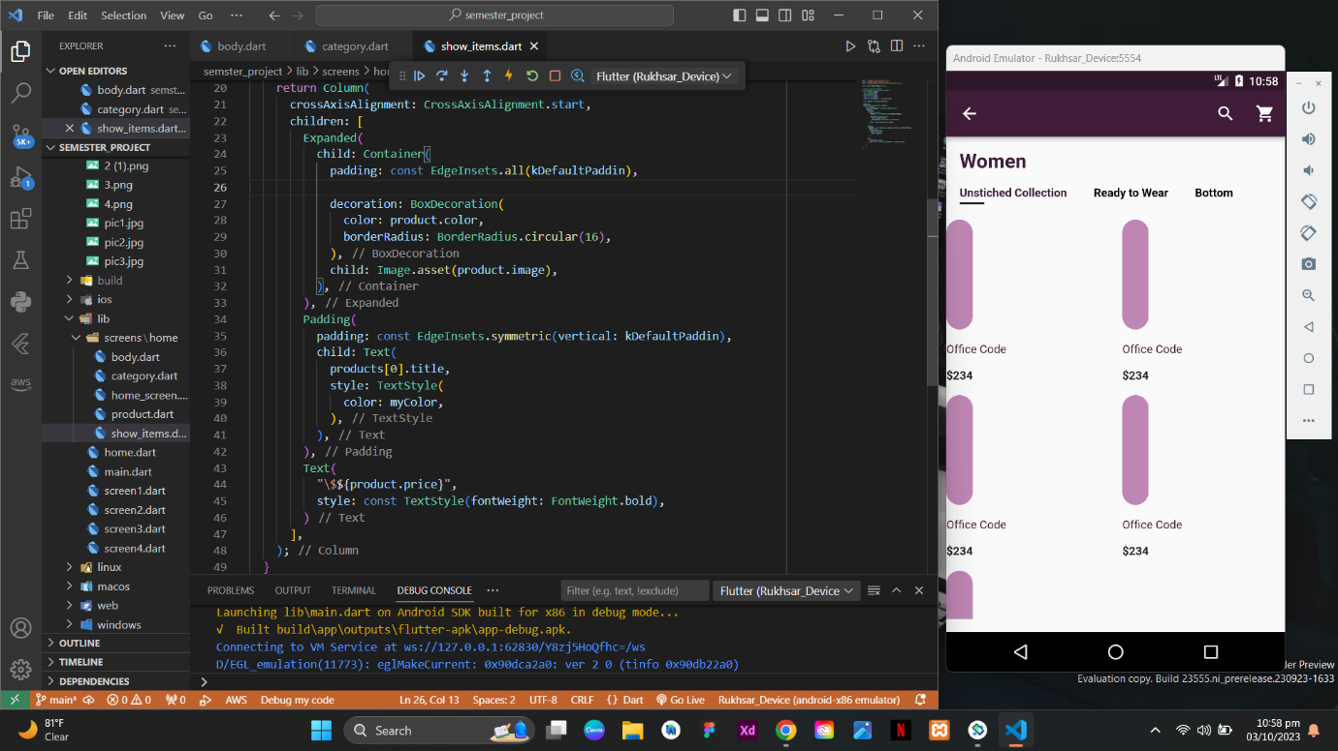

**Problem:**

I have made Container to showcase the products, but in this UI the problem is occurred while runnig the app and I want that title and price is also show within this conatiner.

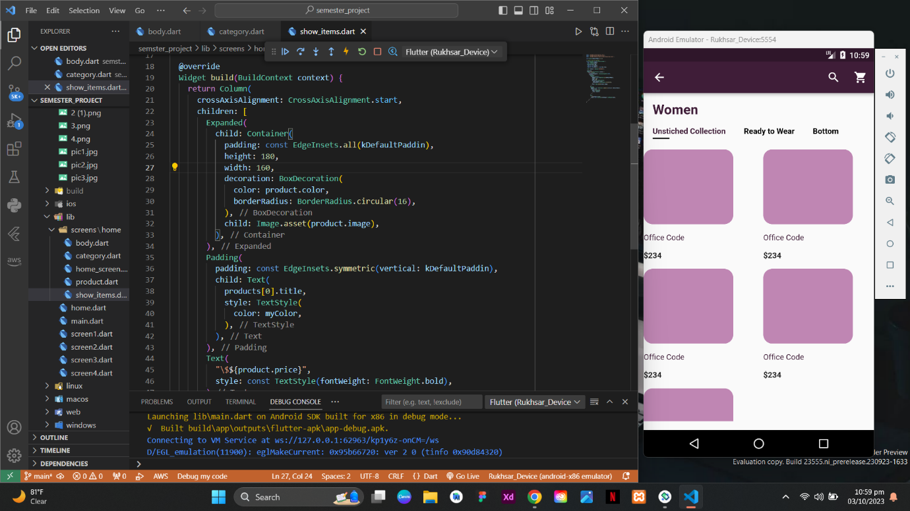

**Solution:**

To encounter this problem, I have set the specific width and height

of each container.

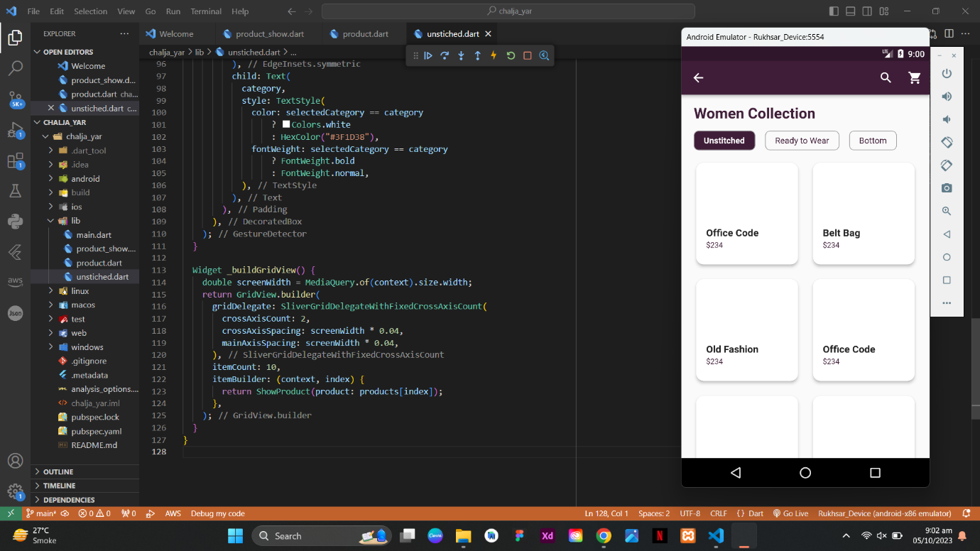

**Solution:**

To encounter this problem, I have use gridview.builder and set itemBuilder and return the ShowProduct class having parameter of Product(model) class using index, it will return the each value in containers.

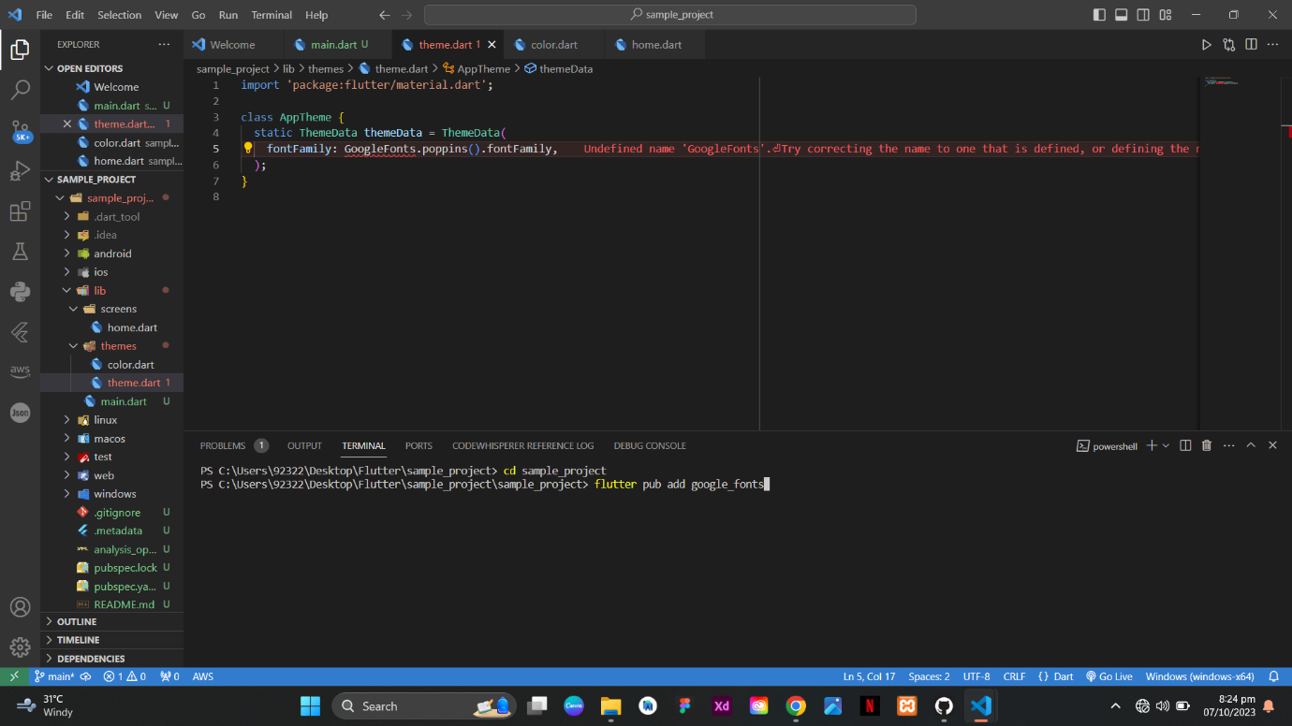

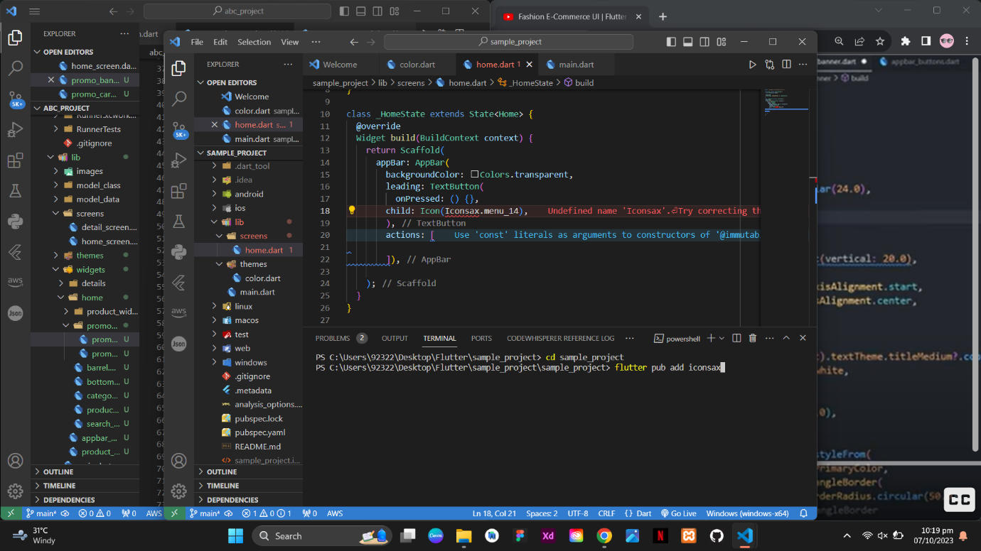

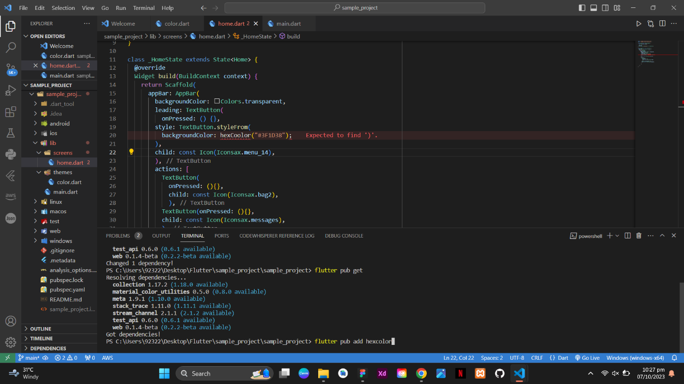

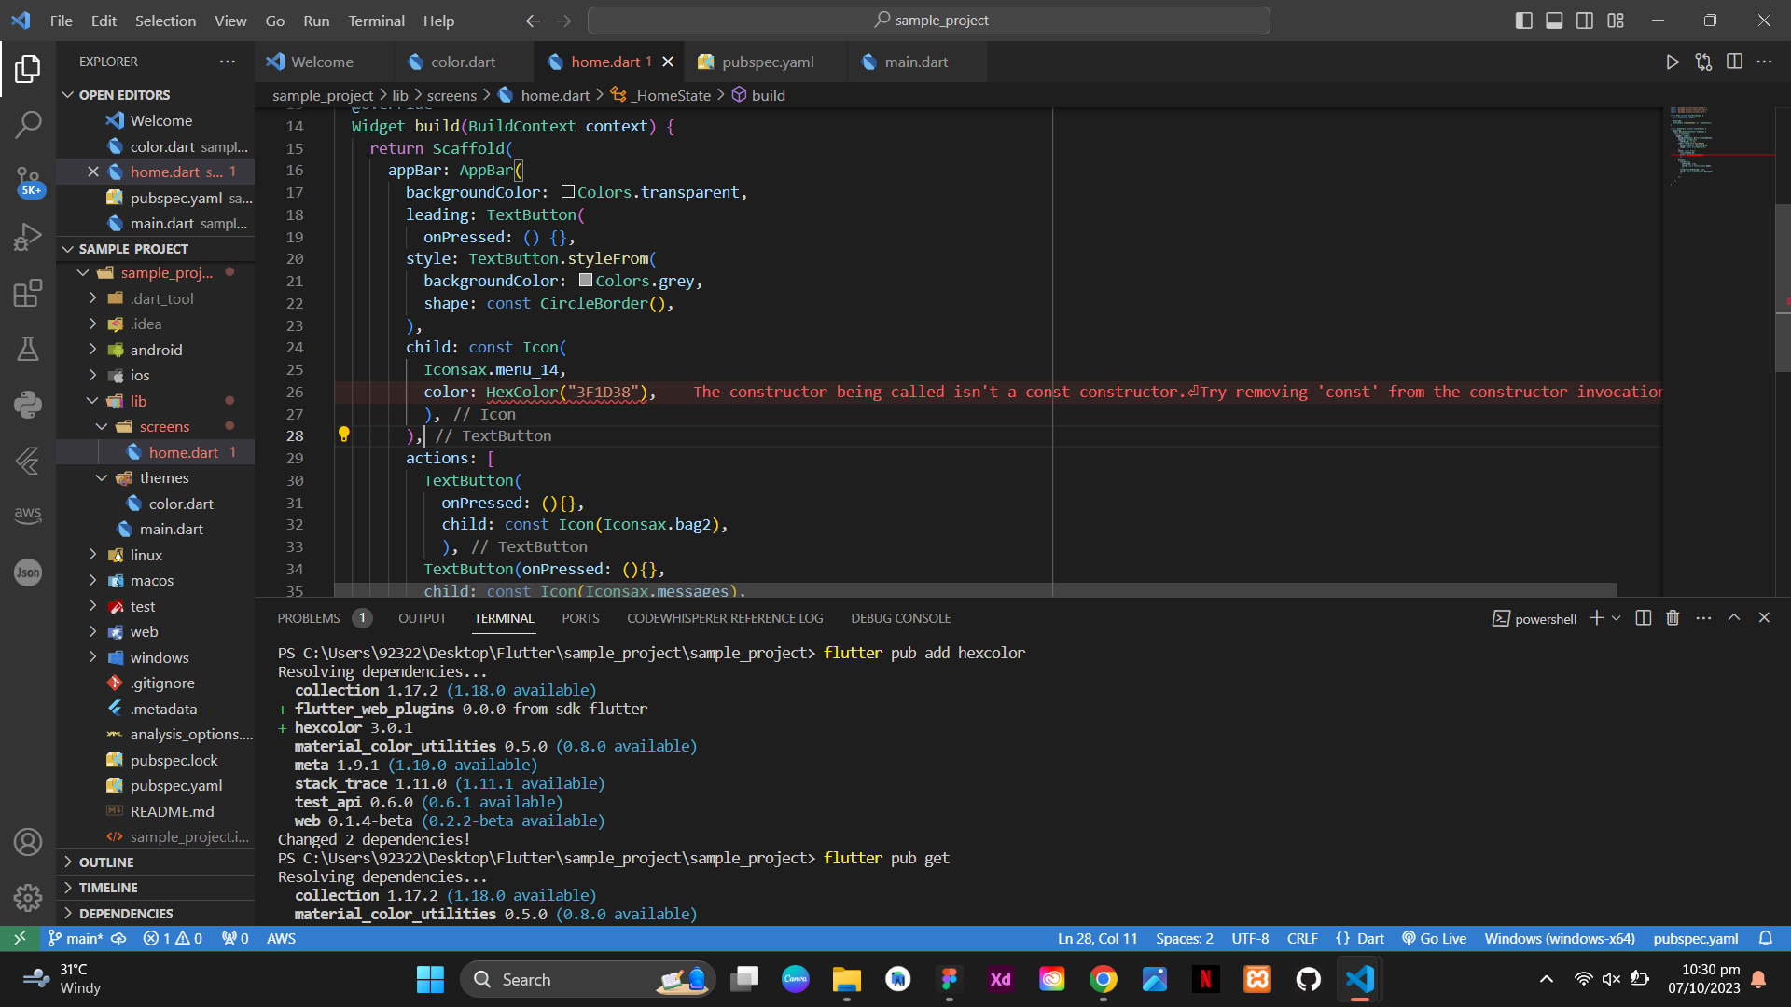

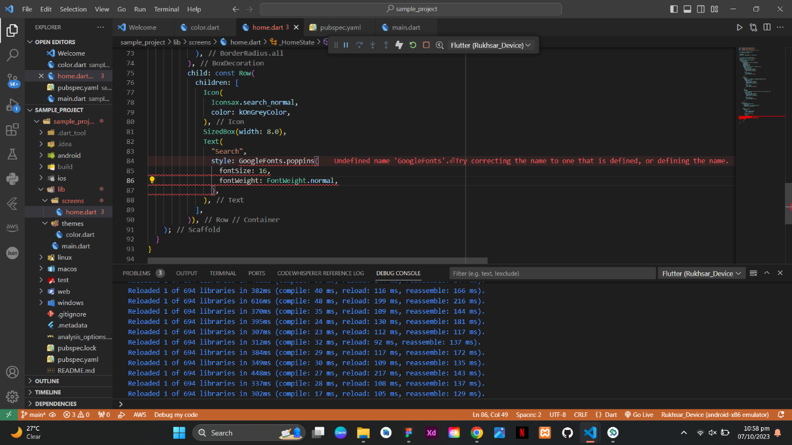

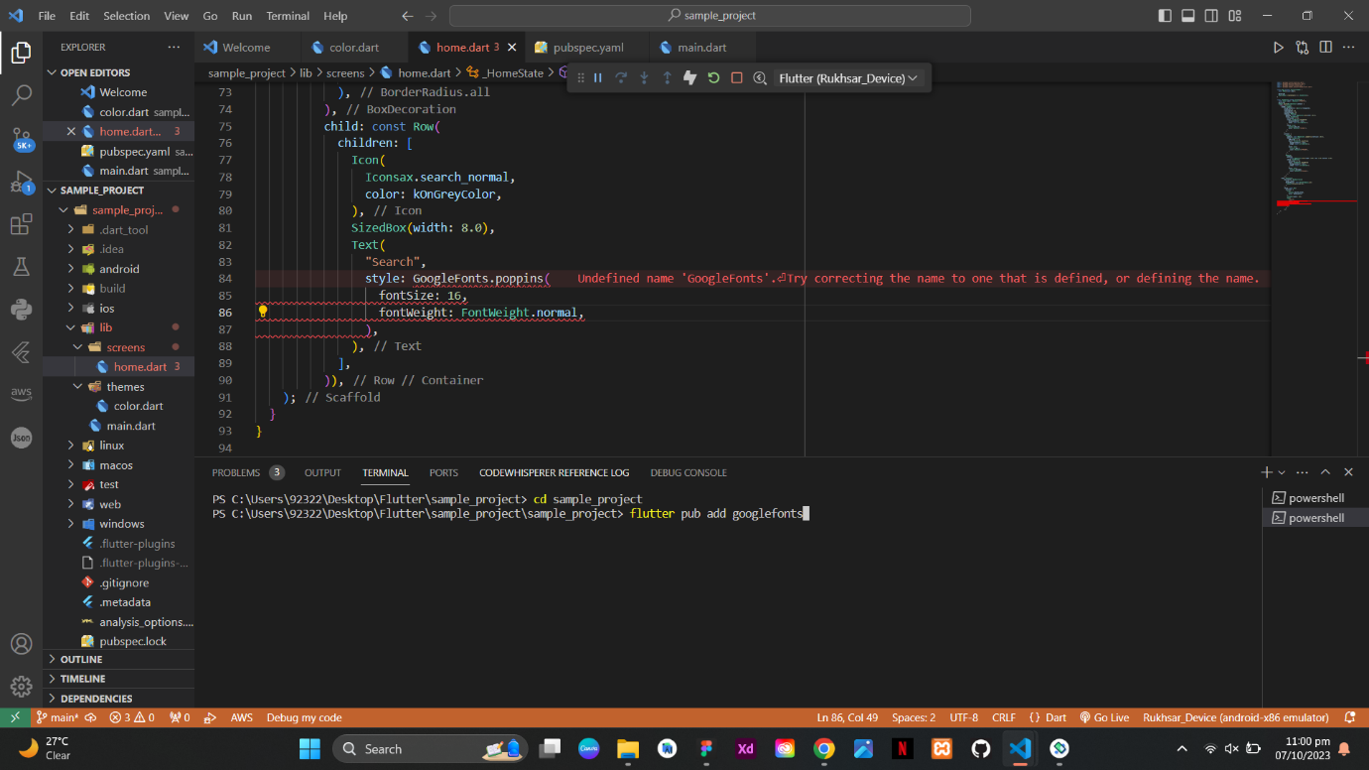

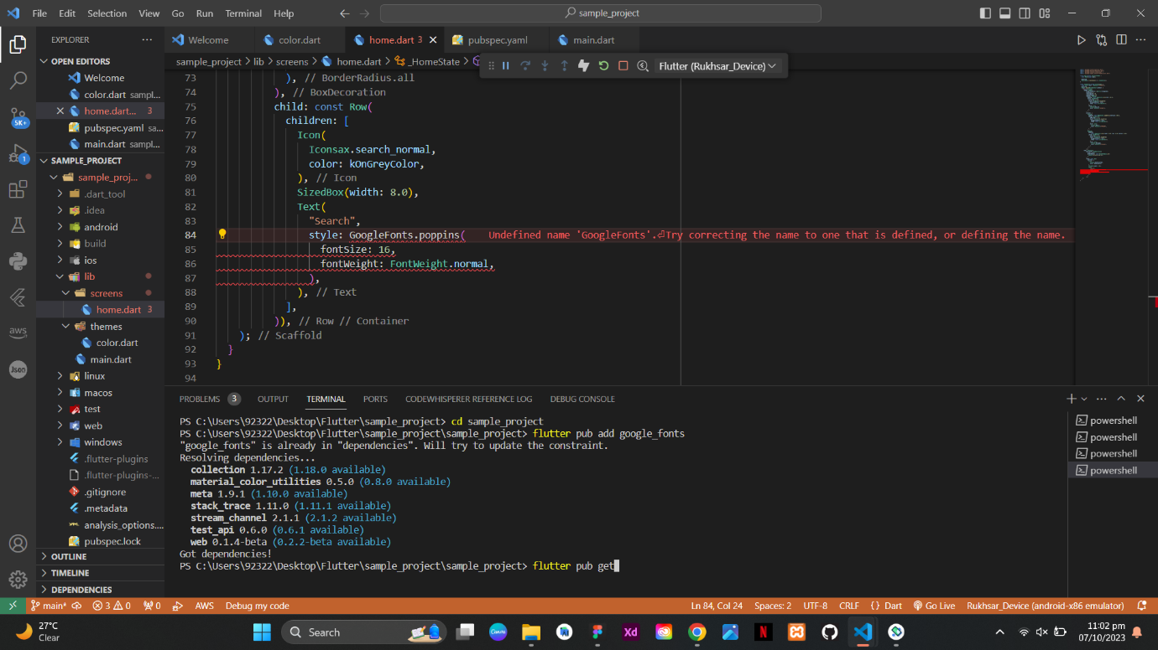

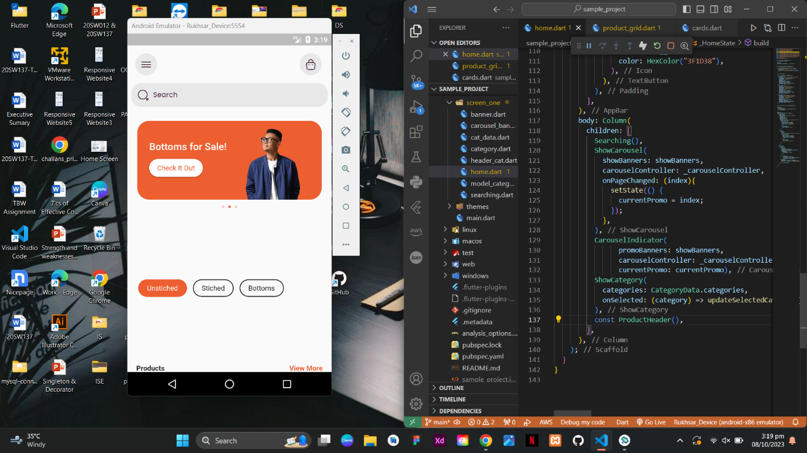

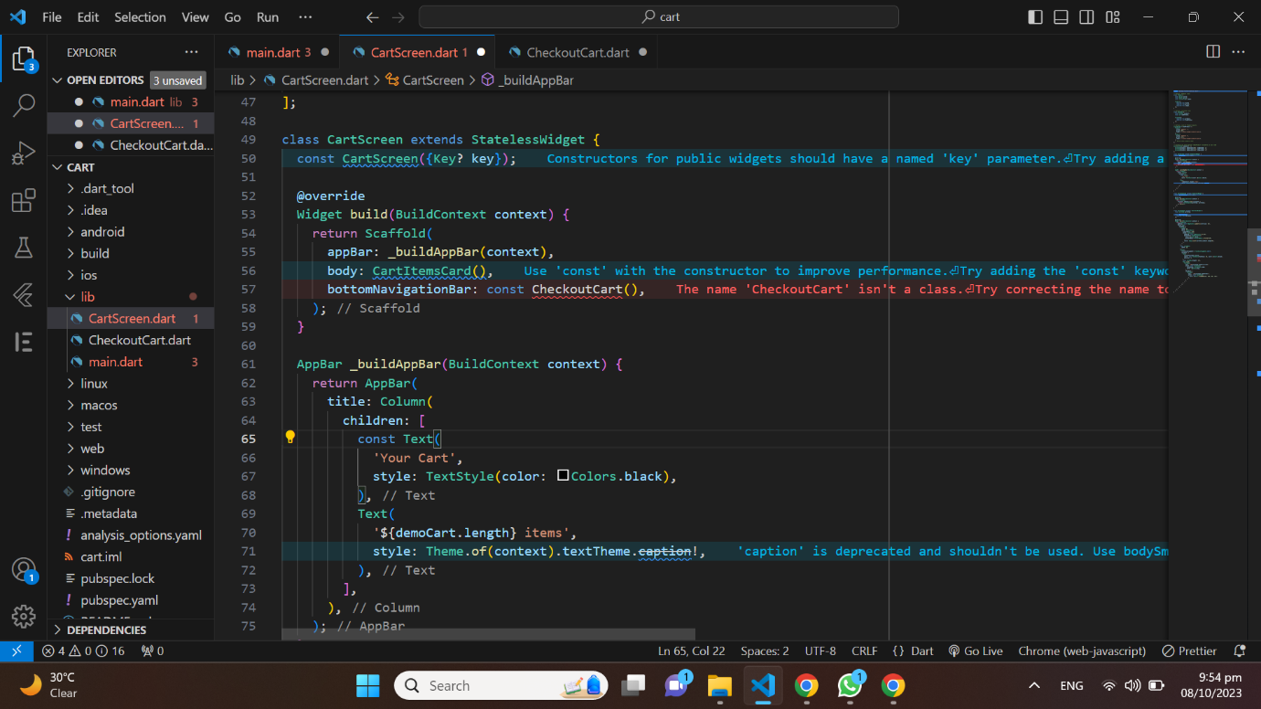

SOLUTION: The issue was resolved by ensuring that the items in the bottom navigation bar matched the number of screens defined in the app.

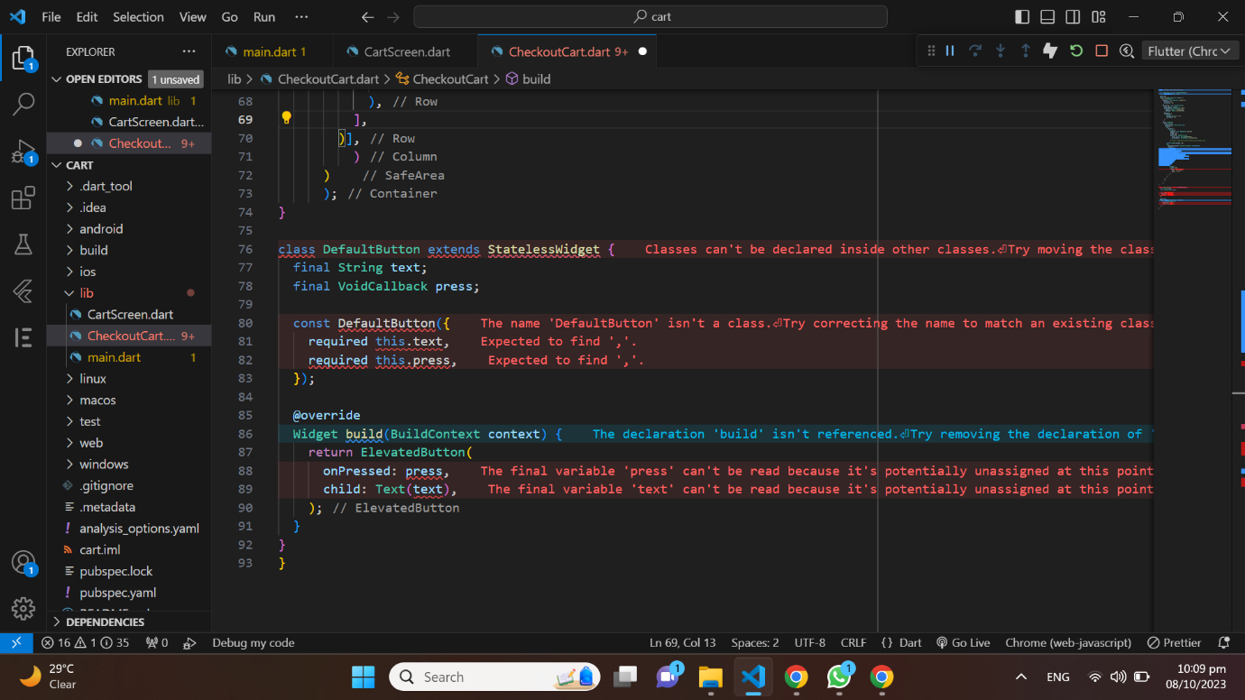

SOLUTION: I resolved the issues in the DefaultButton class by ensuring proper class placement, correct declaration of member variables (text and press), and the appropriate placement of the constructor within the class itself.

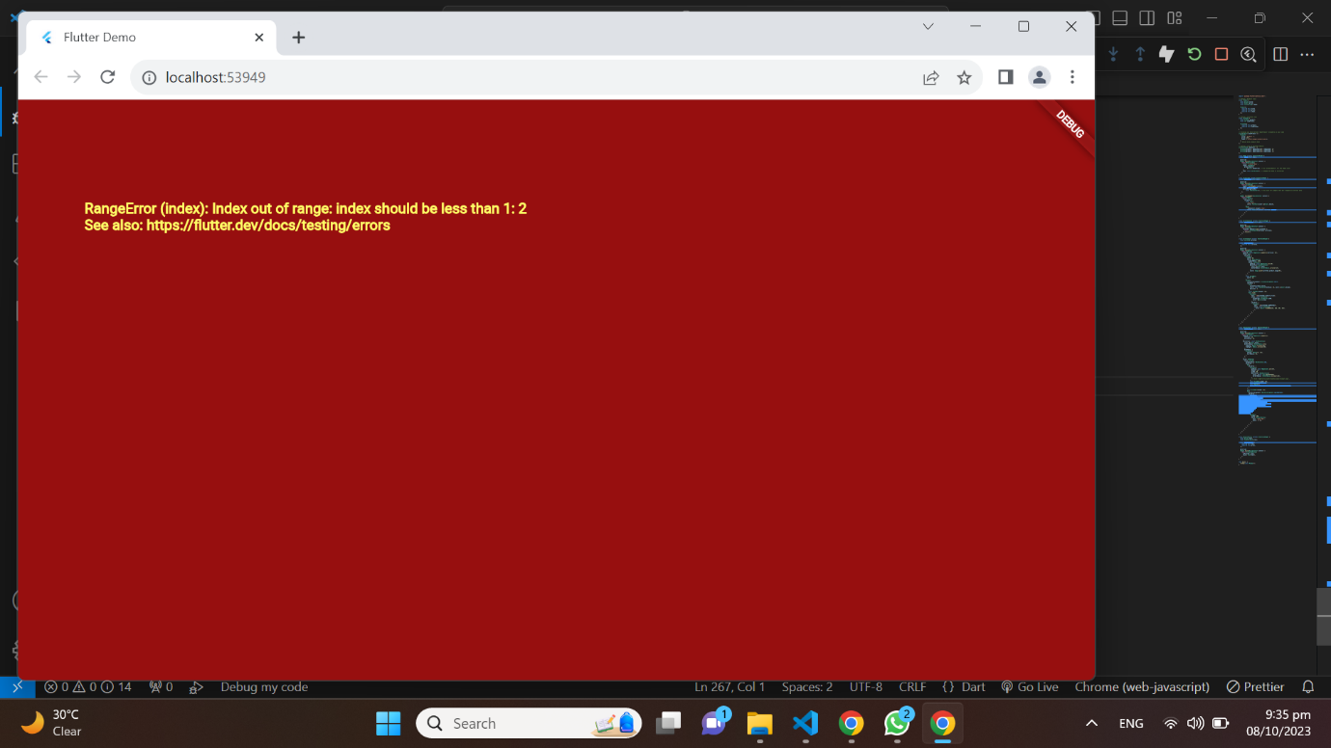

SOLUTION: I resolved the "RangeError: Index should be less than 2; index" issue by checking the range of indices used when accessing elements from a list. This error typically occurs when trying to access an element at an index that is out of bounds of the list. To fix it, I ensured that the index being used to access elements from the list was within the valid range (0 to list. length - 1) and did not exceed the number of elements in the list.